CC impairs N cycling in European beech forests on calcareous soils (Dannenmann et al., 2016)
Why:
- European beech forests growing on marginal calcareous soils have been proposed to be vulnerable to decreased soil water availability. This could result in a large-scale loss of ecological services and economical value in a changing climate.

What
- we investigated the influence of simulated climate change (increased temperatures, reduced soil water availability) on soil gross microbial N turnover and plant N uptake in the beech-soil interface of a typical mountainous beech forest stocking on calcareous soil in SW Germany.

How
- triple 15N isotope labelling of intact beech seedling-soil-microbe systems was combined with a space-for-time climate change experiment.

Results:

- We found that nitrate was the dominant N source for beech natural regeneration
- Reduced soil water content caused a persistent decline of ammonia oxidizing bacteria and therefore, a massive attenuation of gross nitrification rates and nitrate availability in the soil.
- Consequently, nitrate and total N uptake of beech seedlings were strongly reduced so that impaired growth of beech seedlings was observed already after one year of exposure to simulated climatic change.

Conclusion:

- We conclude that the N cycle in this ecosystem and here specifically nitrification is vulnerable to reduced water availability, which can directly lead to nutritional limitations of beech seedlings.
- This tight link between reduced water availability, drought stress for nitrifiers, decreased gross nitrification rates and nitrate availability and finally nitrate uptake by beech seedlings could represent the Achilles’ heel for beech under climate change stresses.

Potential distr. of beech forests on calcareous soils in Europe (modelled)
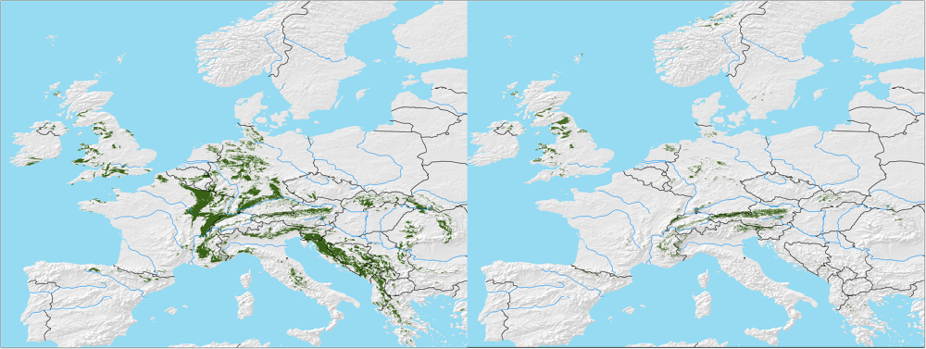

Characteristics of N fluxes in calcareous soils
Ammonia: (might not be an issue in Forests)
In the soil solution, the ammonia gas is in equilibrium with ammonium ions according to the following reversible reaction:

NH₄⁺ + OH⁻ → H₂O + NH₃ ↑

From the above equation it is obvious that ammonia volatilization will be more pronounced at high pH levels (pH>7.5). On the other hand, ammonia-gas-producing amendments will drive the reaction to the left, raising the pH of the solution in which they are dissolved. When a moist soil dries, the water is moved from the right-hand side of the equation, again driving the equation to the right, encouraging ammonia volatilization.

Soil colloids, both clay and humus, adsorb ammonia gas, so ammonia losses are greatest where low quantities of these colloids are present or where the ammonia is not in close contact with the soil. For these reasons, ammonia loss can be quite large from sandy soils and from alkaline or calcareous soils, especially when the ammonia-producing materials are left at or near the soil surface and when the soil is drying out. High temperatures, as often occur on the surface of the soil, also favor the volatilization of ammonia.

(Taalab et al., 2019)

Impact of CaCO₃: (Taalab et al., 2019)
The presence of CaCO3 directly or indirectly affects the chemistry and availability of nitrogen, phosphorus, iron, zinc, magnesium, calcium, potassium and copper (Marschner, 1995).

P, Fe, Zn:
The availability of phosphorus is reduced by the level of calcium and magnesium that are associated with carbonates. In addition, iron, zinc and magnesium deficiencies are common in soils that have high CaCO3 due to reduced solubility at alkaline pH values (Marchner, 1995).

Acid and calcareous soils affect nitrogen nutrition and organic nitrogen uptake by beech seedlings (Fagus sylvatica L.) under drought, and their ectomycorrhizal community structure DOI: 10.1007/s11104-016-2956-4
(Leberecht et al., 2016)
Aims:
The role of different soil types for beech productivity and drought sensitivity is unknown. The aim of this experimental study was to compare mycorrhizal diversity between acid sandy and calcareous soils and to investigate how this diversity affects tree performance, nitrogen uptake and use efficiency (NUE).
Methods:
Beech trees were germinated and grown in five different soil types (pH 3.8 to 6.7). One-and-a-half-year-old plants were exposed for 6 weeks to sufficient or low soil humidity. Tree biomass, root tip mycorrhizal colonization and community structure, root tip mortality, leaf area, photosynthesis, nitrogen concentrations, NUE and short-term 15N uptake from glutamine were determined.
Results:
Soil type did not affect photosynthesis or biomass formation, with one exception in calcareous soil, where root mortality was higher than in the other soil types. Beech in acid soils showed lower mycorrhizal colonization, higher nitrogen tissue concentrations, and lower NUE than those in calcareous soils. Drought had no effect on nitrogen concentrations or NUE but caused reductions in mycorrhizal colonization. Mycorrhizal species richness correlated with nitrogen uptake and NUE. Nitrogen uptake was more sensitive to drought in calcareous soils than in acid soils.
Conclusions:
Beech may be more drought-susceptible on calcareous sites because of stronger decrease of organic nitrogen uptake than on acid soils.

Dannenmann, M., Bimüller, C., Gschwendtner, S., Leberecht, M., Tejedor, J., Bilela, S., Gasche, R., Hanewinkel, M., Baltensweiler, A., Kögel-Knabner, I., Polle, A., Schloter, M., Simon, J., & Rennenberg, H. (2016). Climate change impairs nitrogen cycling in european beech forests. PLoS ONE, 11(7), 1–24. https://doi.org/10.1371/journal.pone.0158823
Leberecht, M., Tu, J., & Polle, A. (2016). Acid and calcareous soils affect nitrogen nutrition and organic nitrogen uptake by beech seedlings (Fagus sylvatica L.) under drought, and their ectomycorrhizal community structure. Plant and Soil, 409(1–2), 143–157. https://doi.org/10.1007/s11104-016-2956-4
Taalab, A. S., Ageeb, G. W., Siam, H. S., & Mahmoud, S. A. (2019). Some Characteristics of Calcareous soils. A review. Middle East Journal of Agriculture Research, 08(01), 96–105.

